EXPERIMENT 1- Comparative Study of Low-Code Development versus Traditional Application Development Approaches

Roll no: 240701247
Name: KAVIYA E
1. Aim
To study and compare the Low-Code Development approach with the Traditional Application Development approach by understanding their workflow, development process, advantages, limitations, and practical applications.

2. Introduction to Traditional Approach
Traditional application development is the conventional method of building software applications by writing source code manually using programming languages such as Java, Python, C#, C++, or JavaScript. Developers follow the Software Development Life Cycle (SDLC), which includes requirement gathering, system design, coding, testing, deployment, and maintenance.
This approach provides complete flexibility and allows developers to create highly customized applications. Since every feature is developed manually, it requires experienced programmers, more development time, and a larger development team. Traditional development is widely used for enterprise applications, banking systems, e-commerce platforms, healthcare systems, and other large-scale software projects where performance, scalability, and security are critical.
Advantages
- High flexibility and customization.
- Better performance for complex applications.
- Strong security and scalability.
- Suitable for enterprise-level projects.
- Easy integration with external systems and APIs.
Limitations
- Longer development cycle.
- Higher development and maintenance costs.
- Requires skilled programmers.
- More debugging and testing effort.

3. Introduction to Low-Code
Low-code development is a modern software development approach that enables users to build applications using graphical interfaces, drag-and-drop components, reusable templates, and automated workflows with minimal manual coding.
Low-code platforms reduce the complexity of software development by providing pre-built modules and visual tools. Developers only need to write code when advanced customization is required. This approach accelerates application development and enables rapid deployment, making it ideal for business applications, workflow automation, and internal management systems.
Popular low-code platforms include Zoho Creator, Microsoft Power Apps, Mendix, OutSystems, and Appian.
Advantages
- Faster application development.
- Minimal coding required.
- Easy to learn and use.
- Lower development cost.
- Rapid deployment.
- Easy maintenance and updates.
- Suitable for rapid application development (RAD).
Limitations
- Limited customization.
- Platform dependency.
- Licensing costs.
- Less suitable for highly complex applications.

4. Diagram for Stages in Traditional Approach
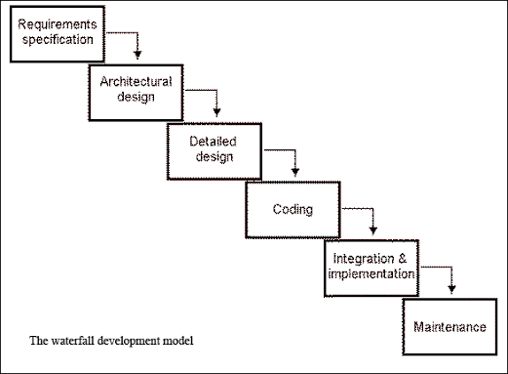

5. Diagram for Steps in Low-Code
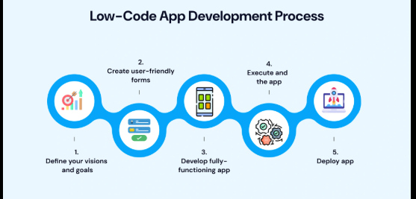

6. Comparative Analysis (Tabulation)
Parameter | Traditional Development | Low-Code Development
Development Method | Manual programming | Visual development
Coding Requirement | High | Low
Development Speed | Slow | Fast
Development Cost | High | Lower
Time to Market | Longer | Shorter
Skill Requirement | Professional developers | Developers and business users
User Interface Design | Manual coding | Drag-and-drop interface
Customization | Very High | Moderate
Flexibility | High | Moderate
Scalability | High | Moderate to High
Testing | Manual | Built-in testing support
Deployment | Complex | Quick and simple
Maintenance | More effort | Easier
Learning Curve | Difficult | Easy
Best Used For | Large and complex systems | Business applications and rapid development

Conclusion
Traditional application development offers complete control, flexibility, and scalability, making it suitable for complex and enterprise-level software projects. However, it requires significant coding expertise, development time, and resources.
Low-code development simplifies application creation through visual development tools, reusable components, and minimal coding. It enables faster development, reduces costs, and allows organizations to rapidly build and deploy business applications. While it may have some limitations in customization, it is an efficient solution for developing modern business applications within a shorter time.

